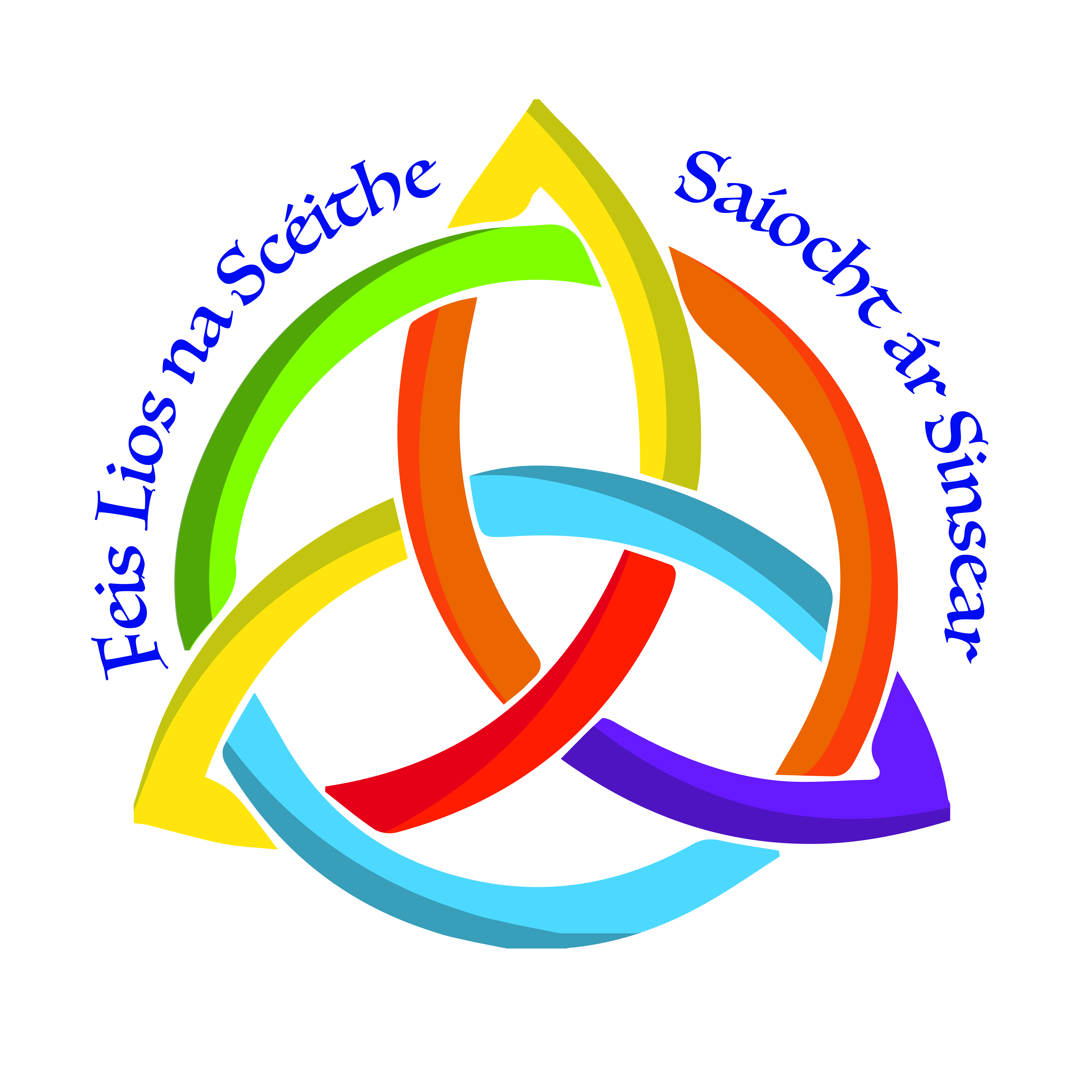
OFFICIAL ENTRY FORM

- It is essential to use a separate Entry Form for each section i.e. Art, Verse Speaking, Irish etc. and for each year group/age section
- CORRECT SPELLING of entrant’s name is vital for recording results and certificates
- Cheques should be made payable to ‘Feis Lios Na Scéithe’ and we now accept PayPal payments via lisnaskeafeis@gmail.com referencing the school name
Name of Teacher or Correspondent ________________________________________________

Address of School or other _________________________________________________

Section(e.g. Art, Verse, etc) | Event No. | Name of Entrant | School Year Group | Fee  Enclosed

